**Experiment 5**

**Student Name: Shreyash Moghe UID:** 22BET10041

**Branch:** BE-IT **Section/Group:** 22BET_IOT-703/A

**Semester:** 6th **Date of Performance:** 28-02-25

**Subject Name:** Project based learning in Java **Subject Code:** 22ITH-359

**Problem 1:** Write a Java program to calculate the sum of a list of integers using autoboxing and unboxing. Include methods to parse strings into their respective wrapper classes (e.g., Integer.parseInt()).

# Objectives:

* + - Demonstrate the use of autoboxing (automatic conversion of primitive types to their wrapper class objects) and unboxing (automatic conversion of wrapper class objects to primitive types) while performing arithmetic operations.
    - Implement methods to convert string representations of numbers into their respective wrapper classes using methods like Integer.parseInt().
    - Sum the list of integers while ensuring the use of autoboxing and unboxing to demonstrate their effect.

# Code:

import java.util.ArrayList; import java.util.List; import java.util.Scanner;

public class SumOfIntegers {

// Method to parse a string into an Integer

public static Integer parseStringToInteger(String str) { try {

return Integer.parseInt(str);

} catch (NumberFormatException e) {

System.out.println("Invalid input: " + str + " is not a valid integer."); return null; // Return null if parsing fails

}

}

// Method to calculate the sum of a list of integers public static int calculateSum(List<Integer> integers) {

int sum = 0;

for (Integer number : integers) {

// Unboxing: Integer to int sum += number;

}

return sum;

}

public static void main(String[] args) { Scanner scanner = new Scanner(System.in);

List<Integer> integerList = new ArrayList<>(); System.out.println("Enter integers (type 'done' to finish):");

while (true) {

String input = scanner.nextLine();

if (input.equalsIgnoreCase("done")) {

break; // Exit the loop if the user types 'done'

}

Integer number = parseStringToInteger(input); if (number != null) {

// Autoboxing: int to Integer integerList.add(number);

}

}

// Calculate the sum of the integers in the list int sum = calculateSum(integerList);

System.out.println("The sum of the entered integers is: " + sum);

scanner.close();

}

}

# Output:

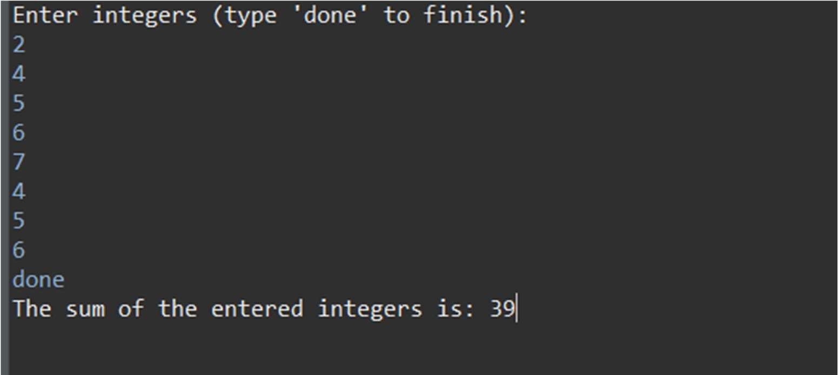

**Fig:1** Sum of elements of array

# Learning Outcomes:

* + - Learn how Java automatically converts primitive types to their corresponding wrapper classes (autoboxing) and vice versa (unboxing).
    - Recognize the importance of autoboxing/unboxing in arithmetic operations and collections like ArrayList<Integer>.
    - Gain experience in working with Java wrapper classes (Integer, Double, etc.).
    - Learn how to convert string representations of numbers into their respective wrapper types using methods like Integer.parseInt().

**Problem 2:** Create a Java program to serialize and deserialize a Student object. The program should:

* Serialize a Student object (containing id, name, and GPA) and save it to a file.
* Deserialize the object from the file and display the student details.
* Handle FileNotFoundException, IOException, and ClassNotFoundException using exception handling.

# Objectives:

* + - Serialize a Student object (id, name, GPA) and save it to a file.
    - Deserialize the object from the file and display student details.
    - Handle FileNotFoundException, IOException, and ClassNotFoundException using exception handling.

# Code:

import java.io.*;

import java.util.Scanner;

class Student implements Serializable {

private static final long serialVersionUID = 1L; // For serialization private int id;

private String name; private double gpa;

public Student(int id, String name, double gpa) { this.id = id;

this.name = name; this.gpa = gpa;

}

public int getId() { return id;

}

public String getName() { return name;

}

public double getGpa() { return gpa;

}

@Override

public String toString() {

return "Student ID: " + id + ", Name: " + name + ", GPA: " + gpa;

}

}

public class StudentSerialization {

private static final String FILE_NAME = "student.ser"; public static void serializeStudent(Student student) {

try (ObjectOutputStream oos = new ObjectOutputStream(new FileOutputStream(FILE_NAME))) {

oos.writeObject(student);

System.out.println("Student object serialized successfully.");

} catch (FileNotFoundException e) { System.out.println("File not found: " + e.getMessage());

} catch (IOException e) {

System.out.println("IOException occurred: " + e.getMessage());

}

}

public static Student deserializeStudent() { Student student = null;

try (ObjectInputStream ois = new ObjectInputStream(new FileInputStream(FILE_NAME))) {

student = (Student) ois.readObject(); System.out.println("Student object deserialized successfully.");

} catch (FileNotFoundException e) { System.out.println("File not found: " + e.getMessage());

} catch (IOException e) {

System.out.println("IOException occurred: " + e.getMessage());

} catch (ClassNotFoundException e) { System.out.println("Class not found: " + e.getMessage());

}

return student;

}

public static void main(String[] args) { Scanner scanner = new Scanner(System.in); int choice;

do {

System.out.println("\nMenu:"); System.out.println("1. Serialize Student"); System.out.println("2. Deserialize Student"); System.out.println("3. Exit"); System.out.print("Enter your choice: "); choice = scanner.nextInt(); scanner.nextLine(); // Consume newline

switch (choice) { case 1:

System.out.print("Enter Student ID: "); int id = scanner.nextInt(); scanner.nextLine(); // Consume newline

System.out.print("Enter Student Name: "); String name = scanner.nextLine(); System.out.print("Enter Student GPA: "); double gpa = scanner.nextDouble();

Student student = new Student(id, name, gpa); serializeStudent(student);

break;

case 2:

Student deserializedStudent = deserializeStudent(); if (deserializedStudent != null) {

System.out.println("Deserialized Student Details: " + deserializedStudent);

}

break;

case 3:

System.out.println("Exiting the program."); break;

default:

System.out.println("Invalid choice. Please try again.");

}

} while (choice != 3);

scanner.close();

}

}

# Output:

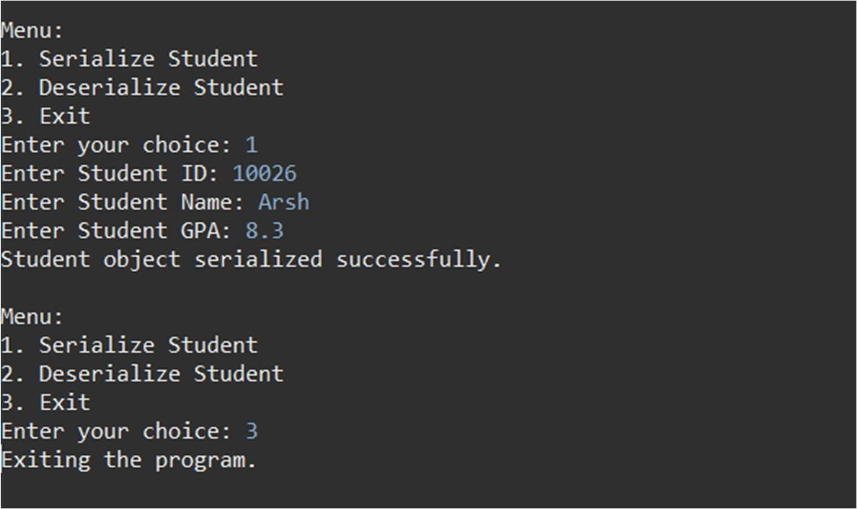

**Fig:2** Student management system using serialization & deserialization

# Learning Outcomes:

* + - Understand the concept of object serialization and deserialization in Java.
    - Learn how to convert a Java object into a byte stream and save it to a file.
    - Gain knowledge of reading and converting a byte stream back into a Java object.

**Problem 3:** Create a menu-based Java application with the following options. 1.Add an Employee 2. Display All 3. Exit If option 1 is selected, the application should gather details of the employee like employee name, employee id, designation and salary and store it in a file. If option 2 is selected, the application should display all the employee details. If option 3 is selected the application should exit.

# Objectives:

1. Create a menu with options to add an employee, display all employees, or exit.
2. Add employee details (name, id, designation, salary) and store them in a file.
3. Display all employee details from the file.

# Code:

import java.io.*;

import java.util.ArrayList; import java.util.List; import java.util.Scanner;

class EmployeeRecord implements Serializable {

private static final long serialVersionUID = 1L; // For serialization private String name;

private int id;

private String designation; private double salary;

public EmployeeRecord(String name, int id, String designation, double salary) { this.name = name;

this.id = id;

this.designation = designation; this.salary = salary;

}

@Override

public String toString() {

return "Employee ID: " + id + ", Name: " + name + ", Designation: " + designation + ", Salary: " + salary;

}

}

public class EmployeeManagement {

private static final String FILE_NAME = "employees.ser"; public static void addEmployee(EmployeeRecord employee) {

List<EmployeeRecord> employees = readEmployees(); employees.add(employee);

try (ObjectOutputStream oos = new ObjectOutputStream(new FileOutputStream(FILE_NAME))) {

oos.writeObject(employees); System.out.println("Employee added successfully.");

} catch (IOException e) {

System.out.println("Error saving employee: " + e.getMessage());

}

}

public static List<EmployeeRecord> readEmployees() { List<EmployeeRecord> employees = new ArrayList<>();

try (ObjectInputStream ois = new ObjectInputStream(new FileInputStream(FILE_NAME))) {

employees = (List<EmployeeRecord>) ois.readObject();

} catch (FileNotFoundException e) {

// File not found, return empty list

} catch (IOException | ClassNotFoundException e) { System.out.println("Error reading employees: " + e.getMessage());

}

return employees;

}

public static void displayEmployees() { List<EmployeeRecord> employees = readEmployees(); if (employees.isEmpty()) {

System.out.println("No employees found.");

} else {

System.out.println("Employee Details:");

for (EmployeeRecord employee : employees) { System.out.println(employee);

}

}

}

public static void main(String[] args) { Scanner scanner = new Scanner(System.in); int choice;

do {

System.out.println("\nMenu:"); System.out.println("1. Add an Employee"); System.out.println("2. Display All Employees"); System.out.println("3. Exit"); System.out.print("Enter your choice: ");

choice = scanner.nextInt(); scanner.nextLine(); // Consume newline

switch (choice) { case 1:

System.out.print("Enter Employee Name: "); String name = scanner.nextLine(); System.out.print("Enter Employee ID: ");

int id = scanner.nextInt(); scanner.nextLine(); // Consume newline System.out.print("Enter Designation: "); String designation = scanner.nextLine(); System.out.print("Enter Salary: "); double salary = scanner.nextDouble();

salary);

EmployeeRecord employee = new EmployeeRecord(name, id, designation,

addEmployee(employee); break;

case 2:

displayEmployees(); break;

case 3:

System.out.println("Exiting the program."); break;

default:

System.out.println("Invalid choice. Please try again.");

}

} while (choice != 3);

scanner.close();

}

}

# Output:

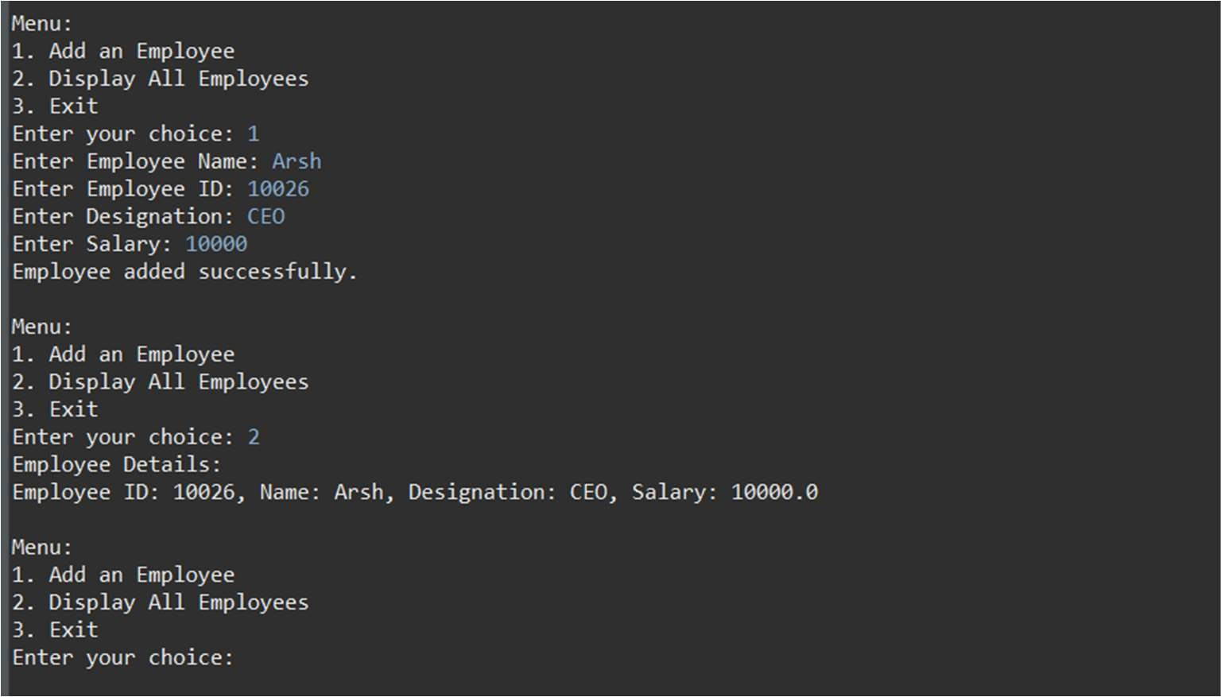

**Fig:3** Employee Details

# Learning Outcomes:

* + - Learn how to create a menu-driven application in Java.
    - Understand how to gather user input and store it in a file.
    - Gain experience in reading from and displaying data stored in a file.
    - Develop skills in managing application flow with user-driven options.